(CL1002) Programming Fundamentals Lab

Lab 5 Task:

▪ Before doing the task, I recommend you all to go through the lab manual. It will make it easy for you all to understand this.

▪ Copied task will be awarded **zero** marks.

▪ Upload only a MS word file including all tasks source code and its output (screen shot). ▪ Note that these lab task marks could be graded through a quiz (viva) in class. ▪ Use the following format for naming the word file Rollno_name (P21-1234_zain).

1. Write a function that takes quantity in pounds and convert it into gram and kilogram Reflect the concept of **required argument**

1 Pound = 453.59237 Grams

1 Pound = 0.454 kilograms

Your program should work as shown below.

**Output:**

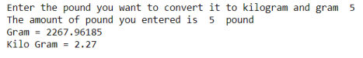

2. Write a function that takes two numbers and perform all arithmetic operations. Function should have **default arguments set to 1, 1**

● Addition

● Subtraction

● Division

● Multiplication

3. Write a function that takes seconds from the user and displays the time in Hours, minutes and seconds’ format. E.g. if the user enters 3700, the output of the program should be

1 Hour 1 minute and 40 seconds.